**GLOBAL ACADEMY OF TECHNOLOGY**

****Approved by AICTE, New Delhi, Recognized by the Govt. of Karnataka

Autonomous Institute affiliated to VTU, Belagavi,

NAAC Accredited with ‘A’ Grade

Ideal Homes Township, RajaRajeshwari Nagar, Bengaluru-98

**Department of Computer Science and Engineering**

**(Accredited by NBA 2019-2022)**

**Academic Year 2021-22**

# 

# Python Programming Mini Project Report

# on

# “SUPERMARKET MANAGEMENT”

*Submitted By*

### Abhay Surya L R [1GA21CS006]

### Chandrashekar K R [1GA21CS042]

### Utham P [1GA21CS174]

### Manoj R [1GA21CS088]

### Manoj S [1GA21CS089]

### Mahesh S [1GA21CS086]

### LikithRaj N [1GA21CS082]

### Aashish V Kulkarni [1GA21CS004]

Under the Guidance of

**Mrs. Vanishree ML**

Assistant Professor, Dept. of CSE, Global Academy of Technology

**GLOBAL ACADEMY OF TECHNOLOGY**

**Department of Computer Science and Engineering**



**CERTIFICATE**

Certified that the II Semester beyond syllabus Python Programming Mini Project Entitled **“TITLE OF THE PROJECT”** carried out by Student Name: Abhay Surya L R USN: 1GA21CS006, Name: Chandrashekar K R USN: 1GA21CS042, Name: Utham P USN: 1GA21CS174, Name: Manoj R USN: 1GA21CS088, Name: Manoj S USN: 1GA21CS089, Name: Mahesh S USN: 1GA21CS086, Name: LikithRaj N USN: 1GA21CS082, Name: Aashish V Kulkarni USN: 1GA21CS004 are bonafide students of Global Academy of Technology, BACHELOR OF ENGINEERING in Computer Science and Engineering during the year 2021-2022. It is certified that all the corrections/suggestions indicated have been incorporated in the report submitted.

________________

Mrs. Vanishree M L

Assistant Professor, Dept. of CSE

GAT, Bengaluru.

**Name of the Students Signature**

Abhay Surya L R __________________

Chandrashekar K R __________________

Utham P __________________

Manoj R __________________

Manoj S __________________

Mahesh S __________________

LikithRaj N __________________

Aashish V Kulkarni __________________

# ACKNOWLEDGEMENT

The satisfaction and euphoria that accompany the successful completion of any task would be incomplete without the mention of the people who made it possible and whose constant encouragement and guidance crowned our efforts with success.

We consider ourselves proud, to be part of **Global Academy of Technology** family, the institution which stood by our way in endeavours.

We express our deep and sincere thanks to our Principal **Dr. N. Rana Pratap Reddy**for his support.

We are grateful to **Dr. Bhagyashri R Hanji,** Professor and HOD, Dept of CSE who is source of inspiration and of invaluable help in channelizing our efforts in right direction.

We wish to thank our internal guide **Mrs. Vanishree M L**, Assistant Professor, Dept of CSE for guiding and correcting various documents of ours with attention and care. She has taken initiative to go through the document and make necessary corrections as and when needed.

We would like to thank the faculty members and supporting staff of the Departmentof CSE, GAT for providing all the support for completing the Projectwork.

Finally, we are grateful to our parents and friends for their unconditional support and help during our Project work.

### Student Names

Abhay Surya L R

Chandrashekar K R

Utham P

Manoj R

Manoj S

Mahesh S

LikithRaj N

Aashish V Kulkarni

**ABSTRACT**

The Project “supermarket” deals with the automation of supermarket. This software will help salespersons in managing the various types of Records pertaining to his/her customer. The product will help the user to work in a highly effective and efficient environment.

 The salespersons have been recording the customer information in the past and even in the present through their personal manual efforts. And indeed, it consumes their considerable time and energy that could be utilized in the better productive activities. Apart from that, with increasing customer Strength, the task of managing information of each individual customer is indeed a cumbersome task.

There is a lot of reason for the introduction of this project. In the manual System, there are number of inefficiencies that a salesperson faces. The information retrieval is one of the foremost problems. It is very difficult to gather the overall performance reports of the customer. Large records-books have to be maintained where relevant and irrelevant information has to be stored which is very untidy and clumsy process. On the other hand, there are many inherent problems that exist in any manual system. Usually, they lack efficiency. Less efficiency has a great impact on the productivity of any human being keeping the data up-to-date.

The 4 automation deals with all such problems and tries to remove them in the best suitable fashion. The new system will cater to the need of the salespersons of any supermarket so that they can manage the system efficiently.

The project “supermarket” is developed with the objective of making the system reliable, easier, fast, and more informative.

# Table of Contents

|  |  |  |
| --- | --- | --- |
| **Sl. No.** | **Chapter Name** | **Page No.** |
| 1 | **Acknowledgement** | 04 |
| 2 | **Abstract** | 05 |
| 3 | **Table of Contents** | 06 |
| 4 | **Chapter 1** | 08 |
|  | * 1. Introduction Python Programming |  |
| 5 | **Chapter 2** | 10 |
|  | 2.1 System Requirements Specification |  |
|  | 2.2 Problem Statement |  |
| 6 | **Chapter 3** | 11 |
|  | 3.1 Program Code |  |
| 7 | **Chapter 4** | 14 |
|  | 4.1 Screenshots |  |
| 8 | **Conclusion** | 15 |
| 9 | **Bibliography** | 16 |

## PROJECT REPORT OUTLINE

1. **CHAPTER 1:**

A brief description of Python Programming Language highlighting its features.

1. **CHAPTER 2:**

System Requirements Specifications:

The Description of required Hardware and software for running the project application.

1. **CHAPTER 3:**

The Program Code.

1. **CHAPTER 4:**

Screenshots displaying outputs in each input case.

**CHAPTER 1**

## INTRODUCTION

**1.1 Introduction to Python Programming**

Python is a widely used general-purpose, high level programming language. It was created by Guido van Rossum in 1991 and further developed by the Python Software Foundation. It was designed with an emphasis on code readability, and its syntax allows programmers to express their concepts in fewer lines of code.

Python is a programming language that lets you work quickly and integrate systems more efficiently.

Before we start Python programming, we need to have an interpreter to interpret and run our programs. There are certain online interpreters like https://[www.onlinegdb.com/,](http://www.onlinegdb.com/) <http://ideone.com/> or <http://codepad.org/> that can be used to run Python programs without installing an interpreter.

**Windows**: There are many interpreters available freely to run Python scripts like IDLE (Integrated Development Environment) that comes bundled with the Python software downloaded from [http://python.org/.](http://python.org/)

**Linux**: Python comes preinstalled with popular Linux distros such as Ubuntu and Fedora. To check which version of Python you’re running, type “python” in the terminal emulator. The interpreter should start and print the version number.

**MacOS**: Generally, Python 2.7 comes bundled with macOS. You’ll have to manually install Python 3 from [http://python.org/.](http://python.org/)

**Why use Python?**

Python, as a high-level programming language, allows you to focus on core functionality of the application by taking care of common programming tasks. The simple syntax rules of the programming language further make it easier for you to keep the code base readable and application maintainable.

* 1. Readable and Maintainable Code
  2. Multiple Programming Paradigms
  3. Compatible with Major Platforms and Systems
  4. Robust Standard Library
  5. Many Open-Source Frameworks and Tools
  6. Simplify Complex Software Development
  7. Adopt Test Driven Development

**CHAPTER 2**

## SYSTEM DEFINITION

### System Requirements Specification

**Software Requirements:**

* Operating system : Windows 10
* IDE : PyCharm
* Programming Language : Python

**Hardware Requirements:**

* Processor : i3 7th Gen
* Memory : 100MB
* Hard Disk Drive : 4GB

**Miscellaneous Requirements:**

* All the required library files and the modules should be available in the include directory.

### Problem Statement

A SuperMarket Management System that allows-

1. Staff to easily access the information regarding to the supermarket.
2. Check for customers required items if present in the inventory.
3. Adding and deleting products.
4. Produce bill

# CHAPTER 3

**IMPLEMENTATION**

**3.1 Program Code**

file=open('miniproject','r')

data=file.readlines()

for i in data:

print(i)

file.close()

items = []

while True:

print('====================Welcome to the supermarket====================')

print('1. View items\n2. Add new items\n3. Purchasing\n4. Searching\n5. Editing\n6. Exit')

op = input('Enter the number of your choice : ')

if op == '1':

print('--------------------View Items--------------------')

print('Total inventory are : ',len(items))

while len(items) != 0:

print('Available items .')

for item in items:

for key, value in item.items():

print(key, ':', value)

break

elif op == '2':

print('--------------------Add items--------------------')

print('Adding new Items ')

item = {}

item['name'] = input('Item name : ')

while True:

try:

item['qty'] = int(input('Item quantity : '))

break

except ValueError:

print('Enter numeric figure :')

while True:

try:

item['price'] = int(input('Price Rs: '))

break

except ValueError:

print('Enter numeric figure')

print('Item has been successfully added.')

items.append(item)

elif op == '3':

print('--------------------purchase items--------------------')

print(items)

pur_item = input('which item do you want to purchase? Enter name : ')

for item in items:

if pur_item.lower() == item['name'].lower():

if item['qty'] != 0:

print('Pay ', item['price'], 'at checkout counter.')

item['qty'] -=1

else:

print('item out of stock.')

elif op == '4':

print('--------------------search items--------------------')

fd_item = input('Enter the item\'s name to search in inventory : ')

for item in items:

if item['name'].lower() == fd_item.lower():

print('The item named '+ fd_item + ' is displayed below with its details')

print(item)

else:

print('item not found')

elif op == '5':

print('--------------------edit items--------------------')

it_name = input('Enter the name of the item that you want to edit : ')

for item in items:

if it_name.lower() == item['name'].lower():

print('current details of '+ it_name)

print(item)

item['name'] = input('Item name : ')

while True:

try:

item['qty'] = int(input('Item quantity : '))

break

except ValueError:

print('Enter numeric figure')

while True:

try:

item['price'] = int(input('Price Rs: '))

break

except ValueError:

print('Enter numeric figure')

print('Item has been successfully updated.')

print(item)

else:

print('Item not found')

elif op == '6':

print('--------------------exited----------------------')

exit()

else:

print('You entered an invalid option')

# CHAPTER 4

## SCREENSHOTS

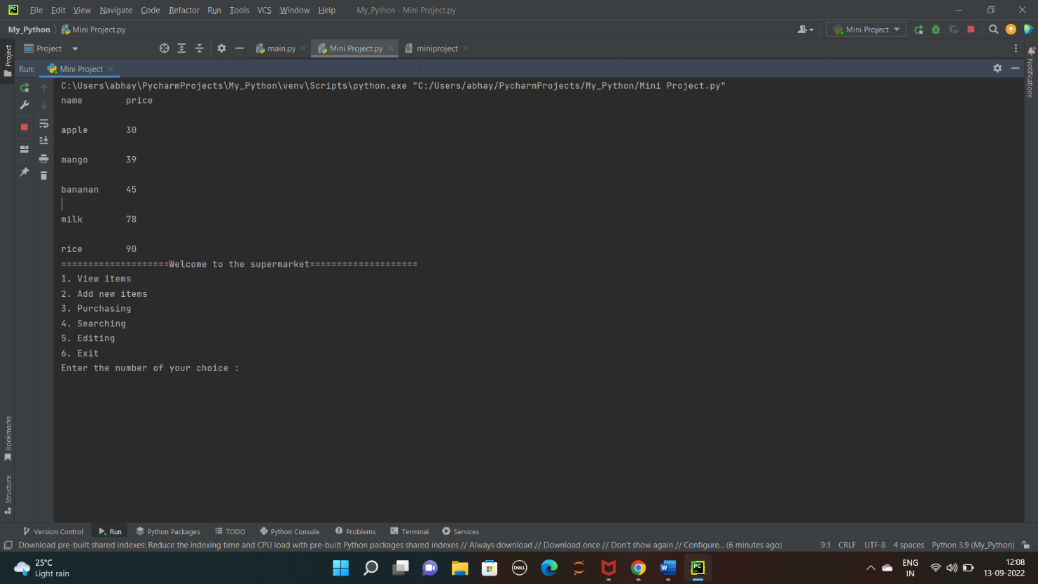

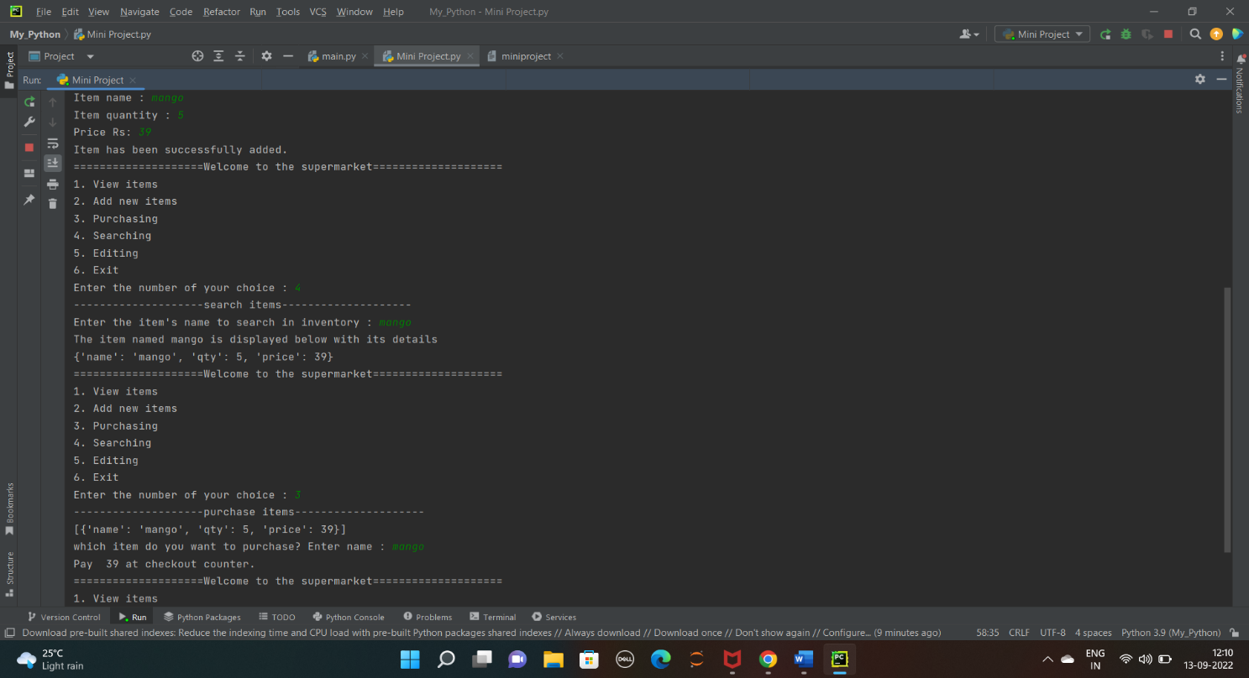

## CONCLUSION

The small and medium-sized supermarket management system use Python and Java language to develop and realize. Procurement and inventory management has always been an essential part of the supermarket.

In order to save money, there still has a lot of small and medium-sized supermarkets uses the way of human purchasing which is waste of time, poor secrecy and low efficiency. These disadvantages will lead to small and medium-sized supermarkets managers faces the difficulties of related documents, query and maintain the data for supermarket.

Supermarket management system realizes the function of procurement management, inventory management, sales management, staff management and membership management that supermarket needed. With the continuous improvement of science and technology, the computer's powerful function has been known and used. Compared with the old manual work, the system not only reduces the workload, but also greatly reduced the occurrence of human error. System can realize the function of the service management informatization so that the staff can observe the conditions of goods inventory and sales at any time. The system also has the advantage of the interface aesthetics, simple operation, convenient query and data storage security, etc. It can gradually improve staff quality and strengthen the management level of the supermarket through the use of the supermarket management system.

The system maintenance is convenient, reliable and has higher security and meet the requirements of practicality.

## BIBLIOGRAPHY

## [1] Automate the boring stuff with Python

## [2] www.academia.edu